6 Reasons Why The Tri-Creaser Fast Fit Will Keep Your Bindery At The Front Of The Pack
Tech-ni-fold Ltd announces the newest result of its ongoing practice of asking for and listening to your suggestions...the new and innovative Tri-Creaser Fast Fit. If you require technology that sets the standards, then the Tri-Creaser Fast Fit is critical
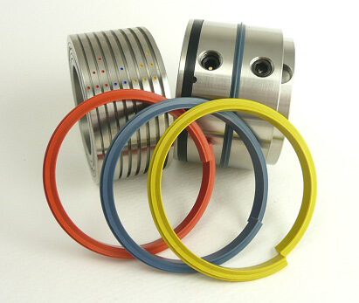
The brand new Tri-Creaser Fast Fit, our most up to date creasing tool including all our latest developments and technologies

Latest Concepts
The Tri-Creaser Fast Fit gives you the ultimate edge by incorporating new concepts into the already remarkable, proven performing Tri-Creaser... a device which has in a short time become the new standard for in-line scoring.
What You Get
Brand new split creasing rib technology allows for instant changeover from one crease setting to another. In seconds, go from scoring the lightest of stocks to the heaviest, without removing the Fast Fit from the shafts.
Colour coded creasing ribs and colour coded female channels. Simplifies operator setup and selection.
Extended life with all new-style creasing ribs. Lasts 50-100% longer than previous O-ring inserts.
Instant push-fit creasing ribs are even easier to put into place than standard O-ring inserts. Simply push sideways onto specially bevelled creasing rib holder.
8 creasing options now available with addition of extra channels on the female. Provides even greater range and greater flexibility for creasing options...all in one tool.
Self-centering female component eliminates the need to lock the female into place. Counter rotating bearing improves scoring on light weight stocks.
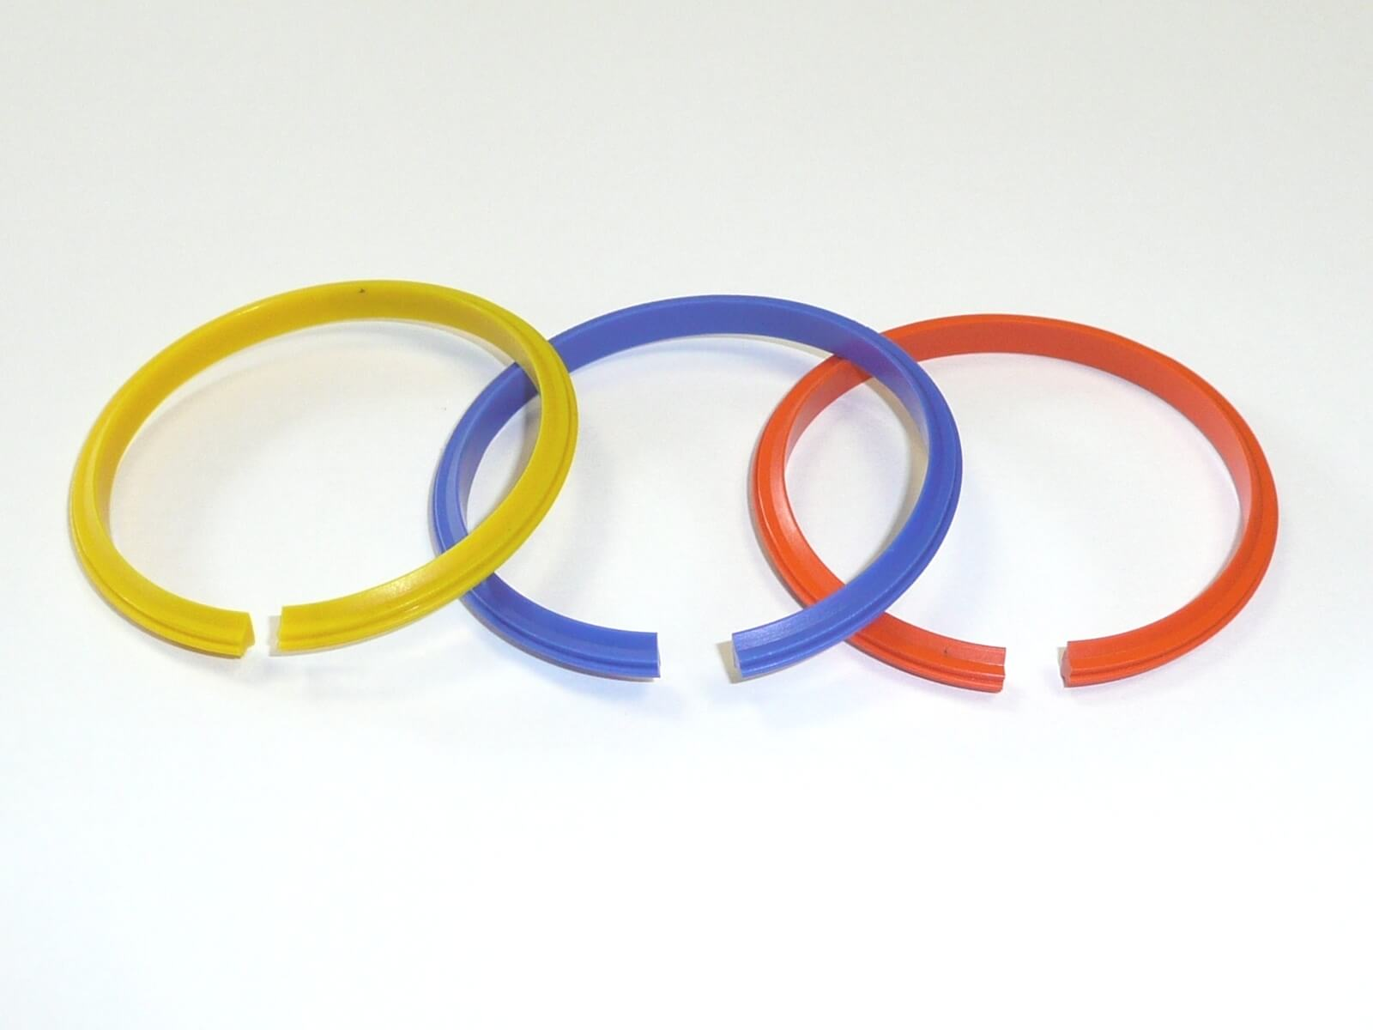
The brand new split creasing rib technology allows for our fastest ever changeover of crease settings and can be done in seconds
All This And More...
Not only do you get these sophisticated upgrades, your new Tri- Creaser Fast Fit delivers what you’ve come to expect in the standard Tri-Creaser:
- Totally eliminates fibre cracking
- Eliminates out-sourcing of creasing jobs
- Dramatic reduction in delivery times
- Eliminates offline press or die scoring
- Saves thousands of pounds year after year
To learn even more about the Tri-Creaser Fast Fit, please visit it’s product page:

